GTB  
  
**QA**  
[LIVE 21.10]OT-1204 | XT | FR | BP | 3.0 Popin - NGC BPA (BPC)

**Jira ticket:**  
<https://jira.uhub.biz/browse/GTBEMEAOPT-1204>

**Site**  
<https://www.ford.fr/>

**Test location**  
See Popin Location

**Test Description**

There are 2 parts to this ticket:

1. Collecting the Data
2. Displaying the popup

It must happen in that order.

NOTE: This ticket only works for vehicles using the new Build and Price configuration (see image below), no data will be recorded if the old configurator is used.

**Collecting the Data:** View the QA Link, in the top right corner select “Configurateur”. To configure a vehicle simply click on it, once loaded, you should now be in the Build and Price section, you can also leave now to trigger a popup. Some popup locations will only appear if you selected a specific model though, so if that is the idea, please select a model before leaving the page in order to get a popup to appear.

**Displaying the Popup:** The popup can display in multiple locations if certain conditions are met.

* Homepage
* NPP of relevant vehicle (eg Fiesta popin to only appear on Fiesta NPP)
* Model Pages of relevant vehicle
* Appear in PV promotions only if it is a personal vehicle
* Appear in CV promotions only if it is a commercial vehicle
* Appear in CV landing page only if commercial vehicle
* If vehicle is present in Mini Showroom -> SUV & Crossover, then show also on SUV page (see footer on Homepage for link)
* If vehicle is present in Mini Showroom -> Hybrid Electric, then show also on Hybrid Electric page (see footer on Homepage for link)
* If vehicle is present in Mini Showroom -> Family Cars, then show also on Family Cars page (see footer on Homepage for link)
* If vehicle is present in Mini Showroom -> Performance, then show also on Performance page (see footer on Homepage for link)
* If vehicle is present in Mini Showroom -> Commercial Vehicles, then show also on Commercial Vehicles page(see Thin Header on Homepage for link)
* If vehicle is ST-line, then show also on ST-line page (see footer on Homepage for link)

The popup can only appear a maximum of 3 times, with a 15 minute duration in between popups. Popups appear after 10 seconds of landing on the page. The CTA on the popup will take the user back to the spot where they dropped off if they had to select from many options, like model or series, but to the next step if it’s colour or interior. If the user made it to the last step before summary, the user will return to this step.

**NOTICE:** Ford has upgraded some of their pages to have a newer style. I don’t know which pages have been upgraded. Our popin code doesn’t currently fire on these pages. If you’re on a page and the popin isn’t appearing. Look at the console for “new solution required” ~ If you see this, the popin won’t appear.

The Popup: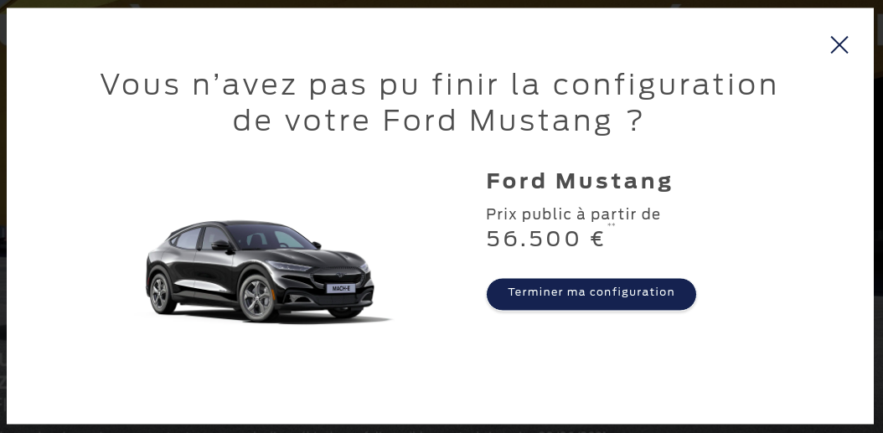

Content of the Popin:

Heading: Vous n’avez pas pu finir la configuration de votre Ford [nameplate] ?

CTA: Terminer ma configuration

Price Information and disclaimers are pulled from the BP journey and could be different for every vehicle.

**Browser:**   
All  
  
**Device:**   
All  
  
**Audience rules:**   
All traffic

**QA Links:**

<https://www.ford.fr?at_preview_token=emdTrOPUPWpBaS3rxaj6DQ&at_preview_index=1_1&at_preview_listed_activities_only=true>